INTRODUCTION

PURPOSE
This document outlines the software and process requirements for the DGEOLOT project. The goal is to visualize parking lot geolocation data (latitude and longitude) using QGIS and publish the visualization to an internal server using IIS Manager for access by the Planner department.

SCOPE
DGEOLOT is an internal GIS data visualization initiative. The system receives geolocation data from a consultant, visualizes it using QGIS by phase, and publishes the results to an internal web server for Planner review. There is no user-facing application; all tasks are carried out by departments using standard tools like QGIS and IIS Manager.

DEFINITIONS, ACRONYMS, AND ABBREVIATIONS
Term | Definition
CDU | Corporate Development Unit
QGIS | Quantum Geographic Information System
SRS | Software Requirements Specification
DGEOLOT | Digitalized Geolocation
GIS | Geographic Information System
IIS | Internet Information Services

PROJECT WORKFLOW

DATA COLLECTION PROCESS
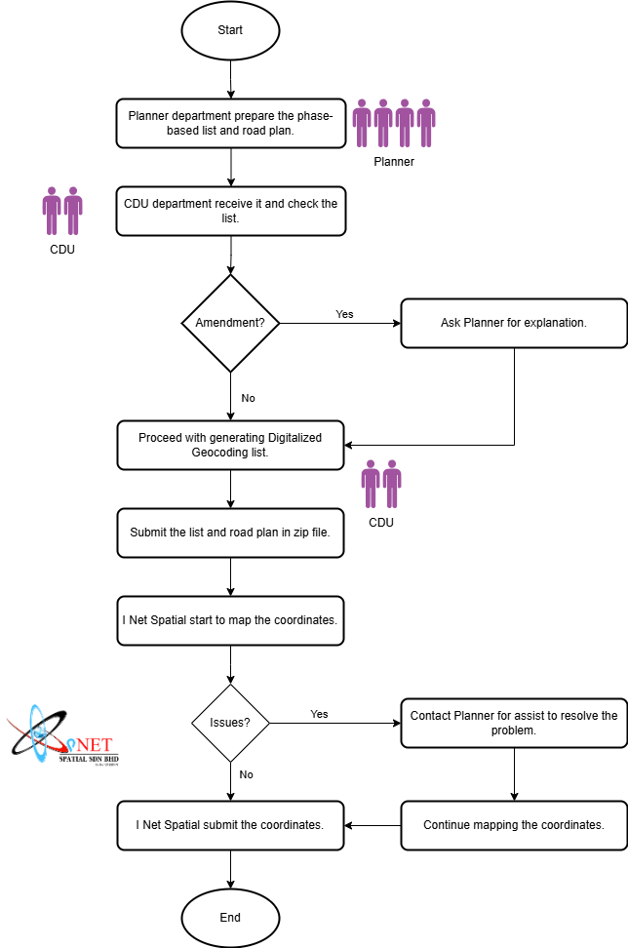
- The Planner Department prepares a phase-based list and corresponding road plan of parking lots that require geolocation.
- The CDU Department reviews the list to verify whether any roads are currently inactive or not in use.
- If inactive roads are identified, the CDU Department requests justification from the Planner Department.
- Once verified, the CDU Department proceeds to generate the Digitalized Geocoding List, including the “Kod Taman” and “Kod Jalan” for each parking lot.
- The finalized list and road plan are compiled into a ZIP file and submitted to the consultant (I Net Spatial Sdn Bhd).
- The consultant uses Google Maps to manually identify and record the latitude and longitude of each parking lot.
- If the consultant encounters any issues, such as roads that cannot be found or matched, the Planner Department will be contacted to assist in resolving the problem.
- Once complete, the geolocation data is returned to the CDU Department in a structured format, such as CSV or Excel.

VISUALIZATION AND PUBLISHING

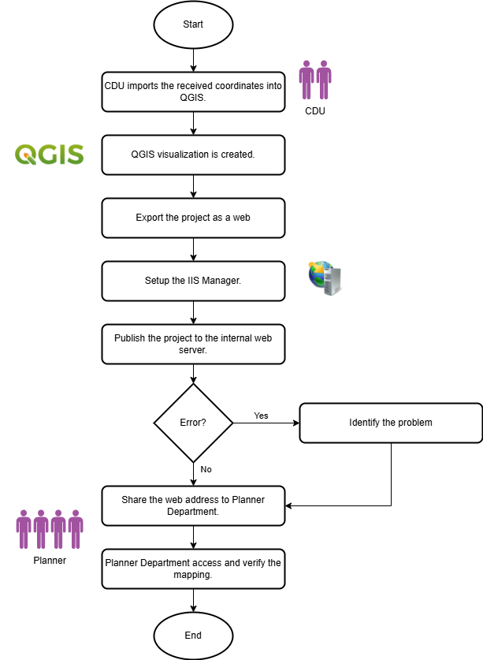
- The CDU Department imports the received coordinate data into QGIS.
- A dedicated QGIS project is created for each phase, with visual markers representing the parking lot locations.
- The project is then exported into a web-friendly format.
- The IIS Manager is configured and set up on the internal server.
- The QGIS project is published to the internal web server.
- If any errors occur during publishing, the CDU Department will troubleshoot, identify the issue, and re-test the publishing method.
- Once successfully published, the access URL is shared with the Planner Department.
- The Planner Department accesses the provided address to review and validate the plotted parking lot locations.

FUNCTIONAL REQUIREMENTS

DATA INPUT
- Accept structured input files in CSV, Excel and GeoJSON format.
- Required fields:
  - Phase
  - Kod Taman
  - Nama Taman
  - Kod Jalan
  - Nama Jalan
  - Parking Lot ID
  - Latitude
  - Longitude
  - Status (Optional)
  - Remarks (Optional)
- Validation:
  - Accept supported formats only.
  - Mandatory fields required.
  - Latitude range: -90 to +90.
  - Longitude range: -180 to +180.
  - Reject duplicate Parking Lot IDs.
  - Display import errors.

QGIS VISUALIZATION
- The system shall:
  - Import coordinate data into QGIS.
  - Use WGS84 (EPSG:4326).
  - Display parking lots as point features.
  - Support visualization by project phase.
  - Display road and housing area information.
  - Allow zoom, pan and identify tools.
  - Display parking lot details when selected.
  - Save project as .qgz.

DEPLOYMENT TO INTERNAL SERVER
- The system shall:
  - Export QGIS project using QGIS2Web or equivalent.
  - Generate HTML, CSS and JavaScript.
  - Publish to IIS.
  - Support project updates.
  - Report deployment errors.

ACCESS CONTROL
- The system shall:
  - Allow access only through the internal network.
  - Provide read-only access to Planner Department.
  - Restrict editing to CDU administrators.

DATA MAINTENANCE
- Replace existing datasets.
- Publish updated phases.
- Maintain project backups.
- Republish after corrections.

ERROR HANDLING
- Detect invalid files.
- Detect missing fields.
- Detect invalid coordinates.
- Detect duplicate records.
- Display publishing errors.

NON-FUNCTIONAL REQUIREMENTS

PERFORMANCE
- Import up to 10,000 records within 2 minutes.
- Load published map within 5 seconds.
- Support at least 20 concurrent users.

AVAILABILITY
- Available during office hours.
- Target uptime: 99%.

SECURITY
- Internal network access only.
- Read-only access for Planner users.
- Administrative access for CDU.

COMPATIBILITY
- QGIS 3.x
- Windows Server with IIS
- Microsoft Edge
- Google Chrome

MAINTAINABILITY
- Support future project phases.
- Easy dataset replacement.
- Easy republishing.

